**Lab-1 Assignment**

**Submitted by:**

**SUBARNA POUDEL  
Student ID: 23002412**

**Submitted to:**

**Professor: Nawaz Chowdhury**

**Subject: Web Development 2**

**Course code: CSD213**

Honesty Statement: “I declare that this submission is my own work in compliance with Sault College Academic Policies.”

**Due date: September 13, 2024**

**Table of Content**

**Assignment Steps** 3

**Assignment Steps-1** 3

**Assignment Steps-2** 4

**Assignment Step-2** 5

# 

# **Assignment Steps**

## **Assignment Steps-1**

Here is my code 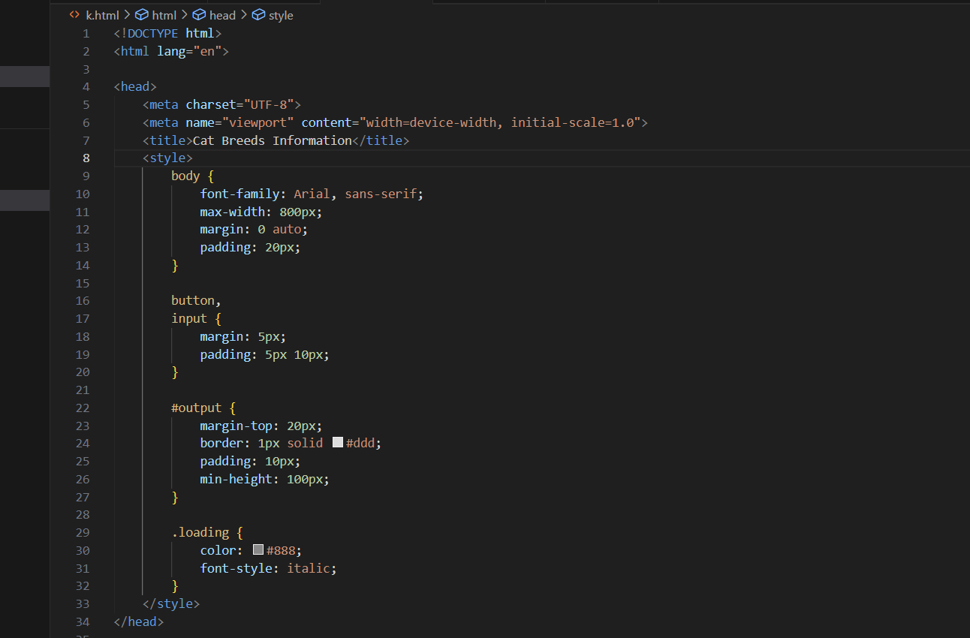

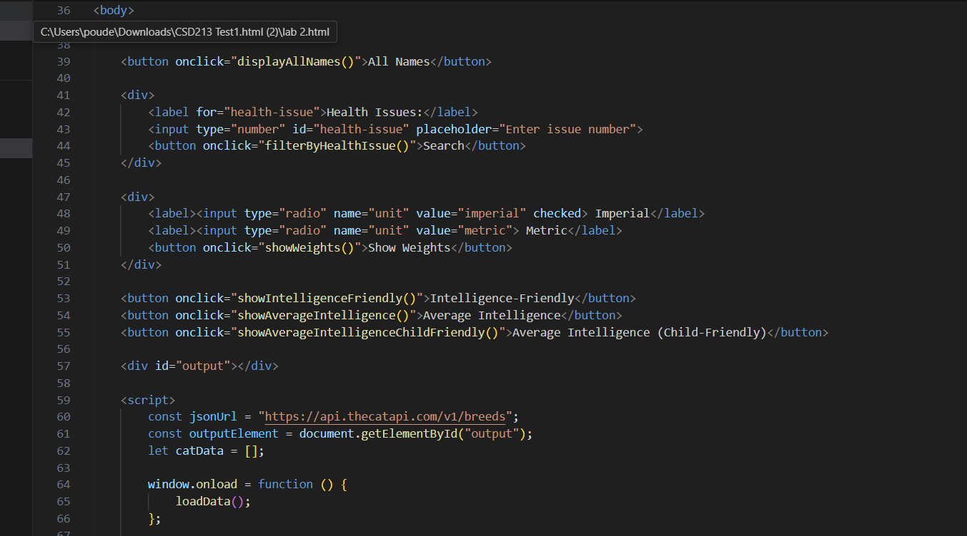

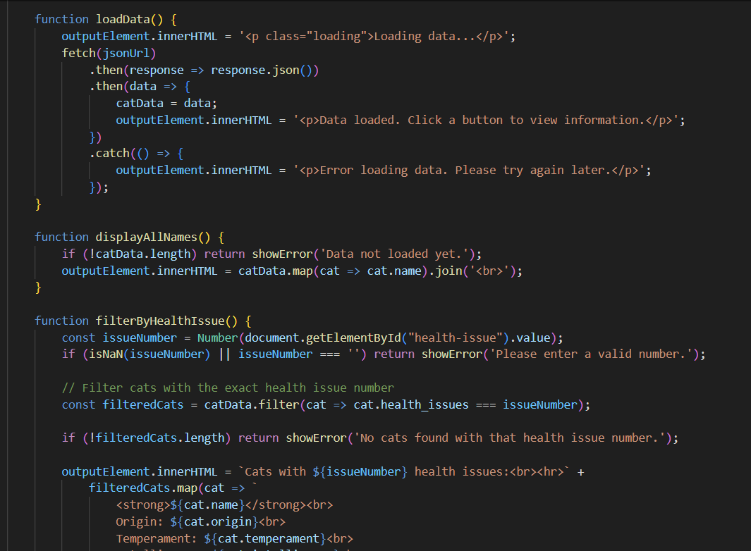

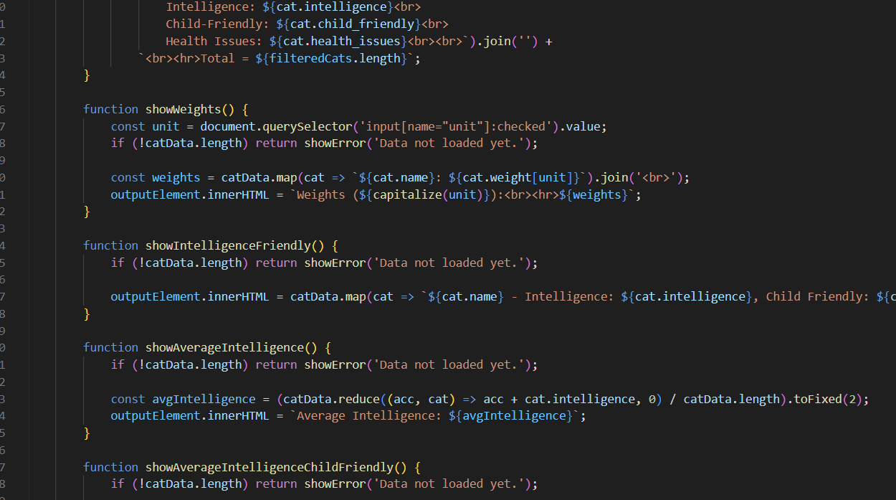

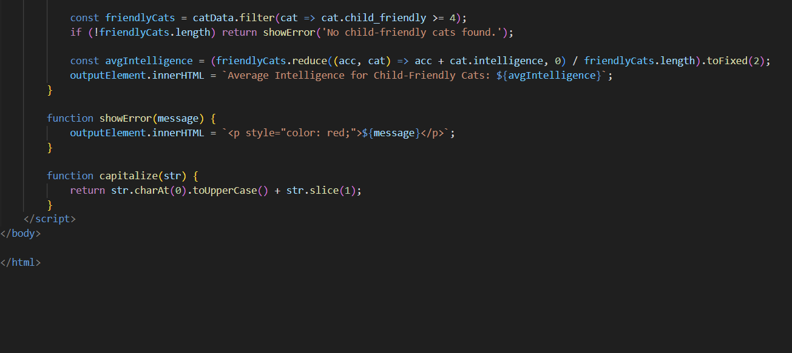

## **Assignment Steps-2**

Here is my output

1 The initial screen for the app should look like this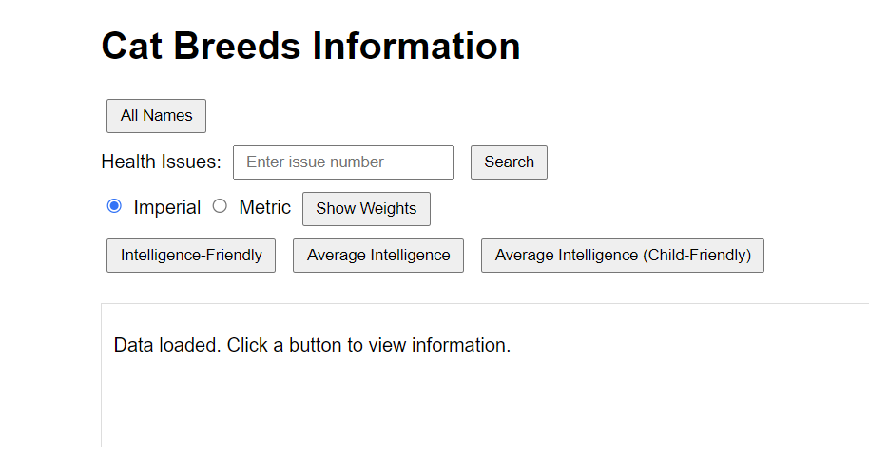2 All Names: Clicking on this button displays the name of all 67 cats.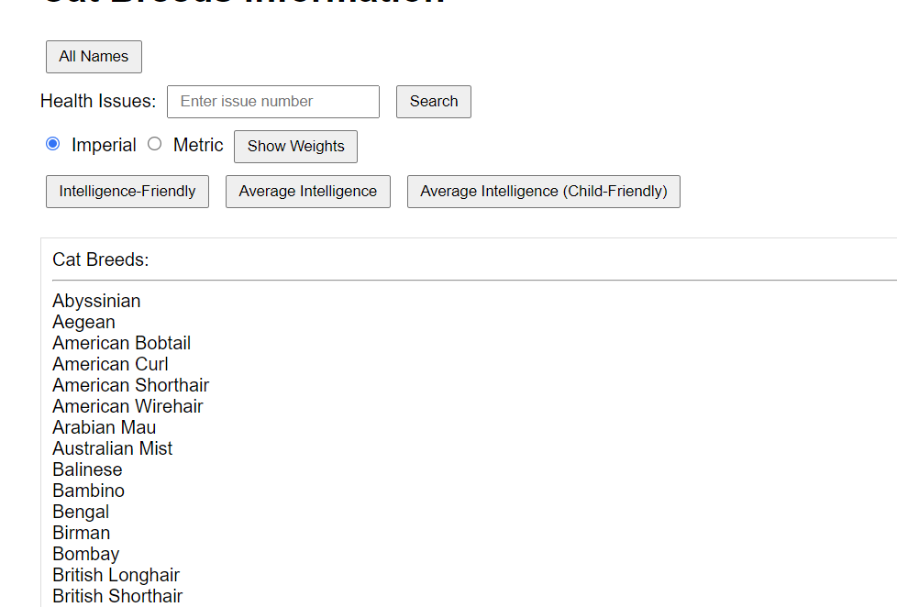

3 Health Issues: Entering a number in this field displays the names of cats with that health issue. For example, entering 2 displays the 11 cats with health issue #2.

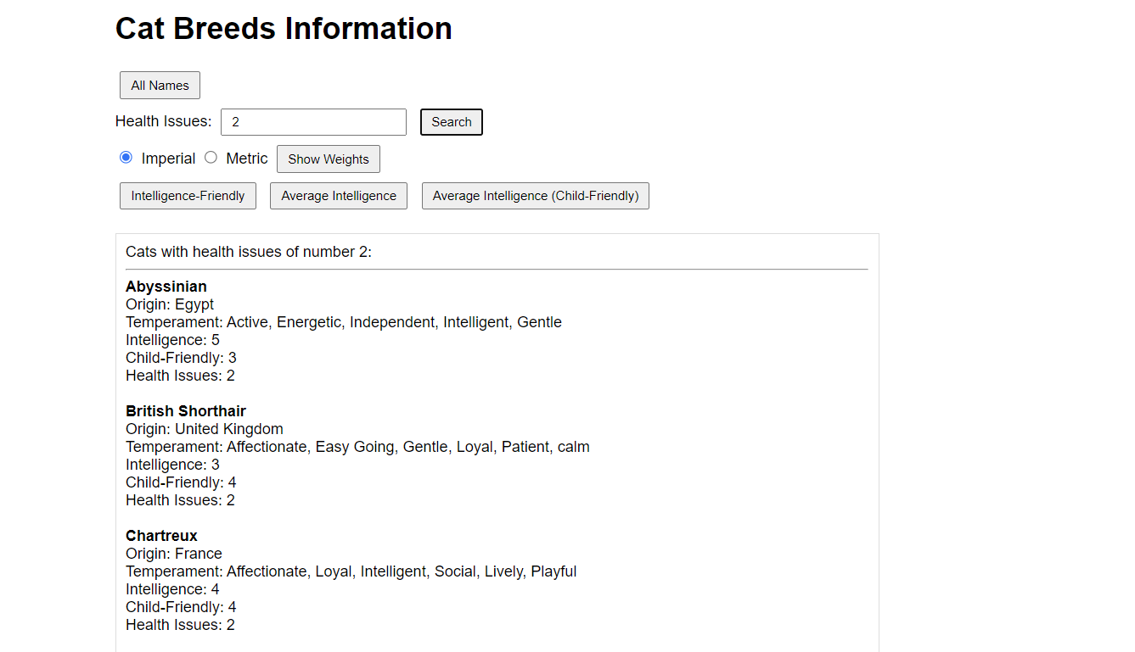

4 Weight: Clicking on the Weight button displays the weights ranges for each of the cats in imperial (the default). If the user selects Metric, the weights are displayed in metric.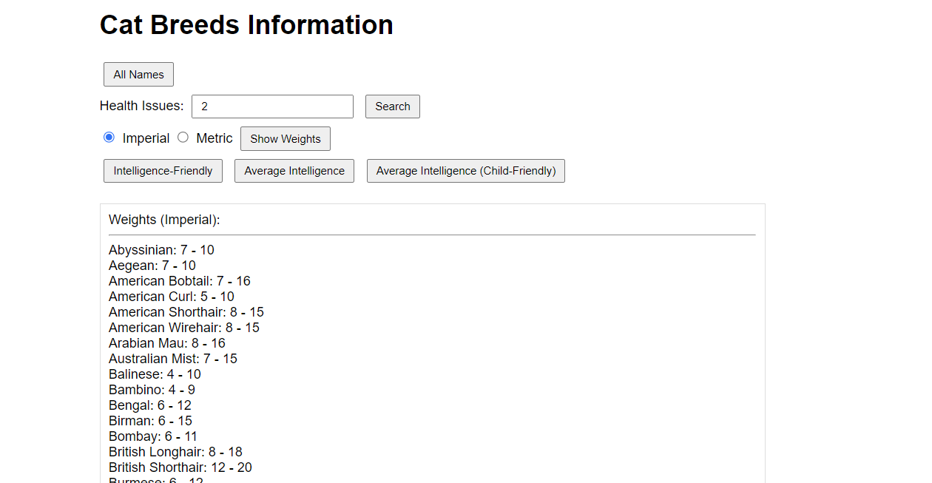

5 Intelligence – Friendly: Clicking on this button displays how intelligent and child friendly all of the cats are. Under I, put the intelligence factor. Under F, put the child-friendly factor.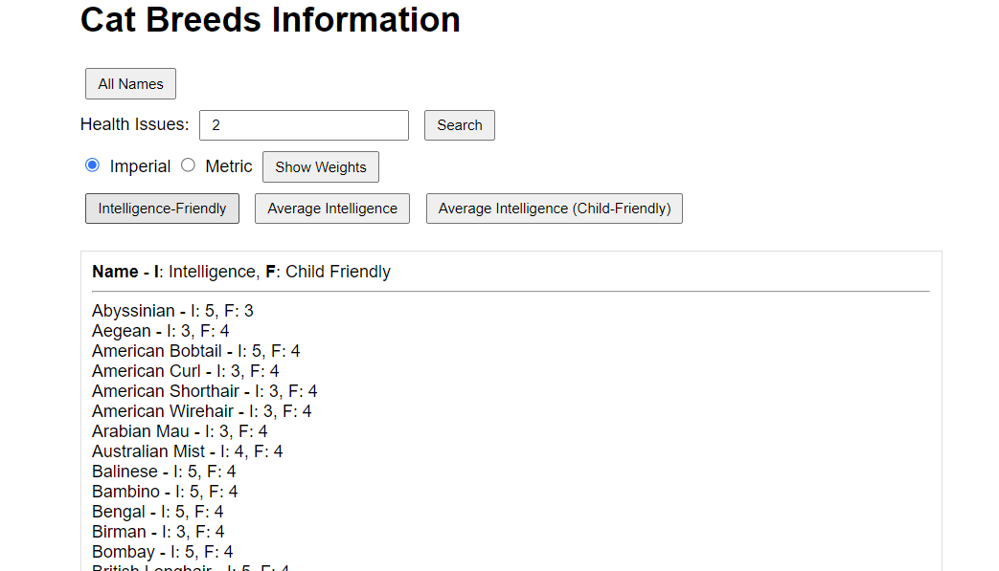

6 Average Intelligence: This displays the average intelligence of all cats.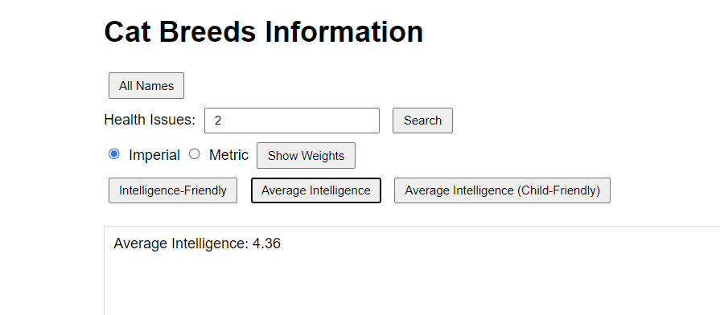

7 Average Intelligence for Child Friendly: This displays the average intelligence of cats that are child friendly.

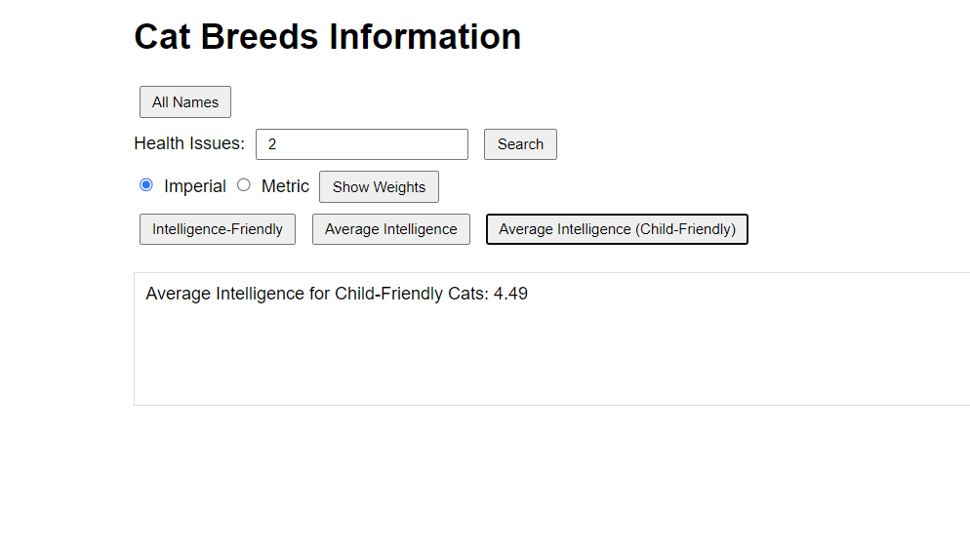

**Thank you.**